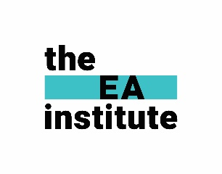
The EA Institute: Request for Professional Development Support Letter
Copy and paste below, edit names and to your suit your tone as necessary.
Good Luck!

Subject: EA Course Curriculum

Hi [Executive or HR Manager's Name],
EA Curriculum Brochure
I am writing to request your support in pursuing professional development through one of the highly regarded courses offered by The EA Institute. Their curriculum is designed to provide Executive Assistants with a robust set of skills to excel in today’s dynamic business environment.
The EA Institute offers a three-step program tailored to different career levels: Essentials for EA Technicians, EA Manager, and EA Leader. Each course equips participants with essential skills, advanced management capabilities, and leadership acumen. With the practical knowledge gained from these courses, I will be better equipped to support our organization’s objectives and contribute at an even higher level.
The benefits of this professional development opportunity include:
- Enhanced Efficiency and Productivity: Mastering essential tools, time management, and project coordination will allow me to streamline processes and optimize my output.
- Strategic Communication and Leadership: Developing advanced communication, strategic thinking, and leadership skills will enable me to navigate complex challenges and build stronger partnerships with key stakeholders.
- Supporting Organisational Goals: By enhancing my ability to manage multiple projects, lead change initiatives, and align my work with organizational strategies, I can directly contribute to our success.
- Certification and Recognition: Completing the course will add value to my professional profile through a recognized credential, reflecting our organization’s investment in employee development.
The course I wish to enrol in is priced at $1,997 + GST AUD, and it is tax deductible. Additionally, I will gain access to a supportive online learning community, flexible content to revisit anytime, and resources to ensure long-term value.
I believe this investment will have a significant return not only in my personal growth but also in how I can elevate my contributions to [Company Name]. I would be happy to discuss this further and provide additional details if needed.
Thank you for considering this request. I am confident that your support in this endeavour will empower me to bring greater value to our team.

Warm regards,

